**SYNTAX:-**

rm [OPTION] [Filename…]

**EXPLANATION:-**

rm command is used to remove the file in current working directory.

Initially the linux folder contains these 5 Files.

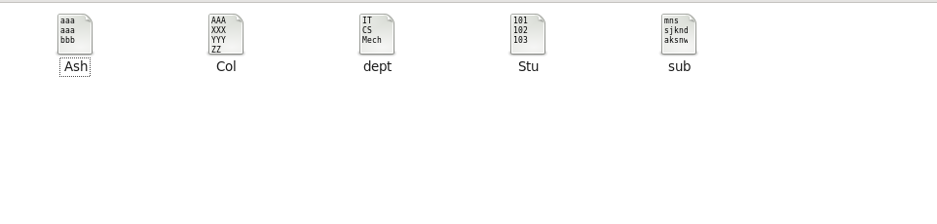

Now we are going to execute the below highlighted command.

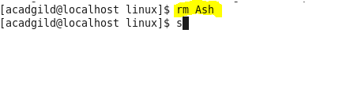

After executing the above command, the file named Ash is removed as shown in the below image.

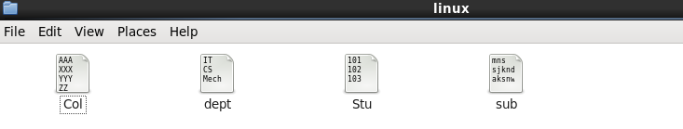

There are few basic options that I am going to explain below:-

1. **rm –i:-**

i(interactive) option in rm command asks the user for confirmation before deleting specified file. If you specify y ( for yes), then that file will be deleted from that directory. If you specify n ( for no), then that file won’t be deleted from that directory.

We are going to execute the below highlighted command.



Here, we gave option y after executing rm –i. So, the file named Col will be removed.

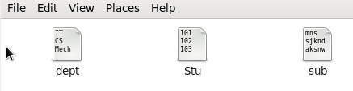

We are going to execute the below highlighted command.



we gave option n after executing rm –i. So, the file named dept won’t be removed.



**2). rm –f:-**

f(force) option in rm command will forcefully remove the file from the directory without prompting the user.

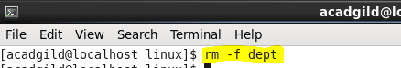

dept file will be removed forcefully as shown in the below screenshot.

